**Embrace Queue APIs integration**

In order to use **EmbraceQueue APIs** please use following steps:

**1.Register** into system using **/api/v1/accounts/register**

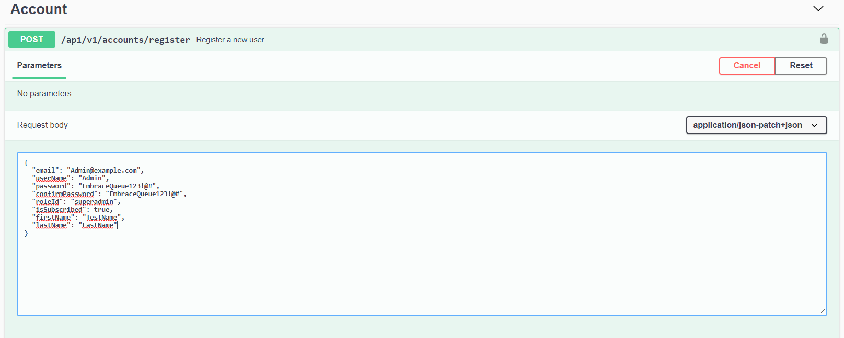

As example, please see attached image. Please be aware of **REQUIRED PROPERTIES**:

**Password**: Length at least 8chars, require non alphanumeric, an uppercase, an lowercase, an unique char and a digit.

**ConfirmPassword**: Should be same as password

**Email**: Should be a valid email and unique

**UserName**: Required

**RoleId**: One from above: **superadmin**, **branchmanager**, **helpdeskemployee**, **enduser**

**2.** **Log in** into system using **/api/v1/accounts/login** with email and password used in register form. Please see attached image as example:

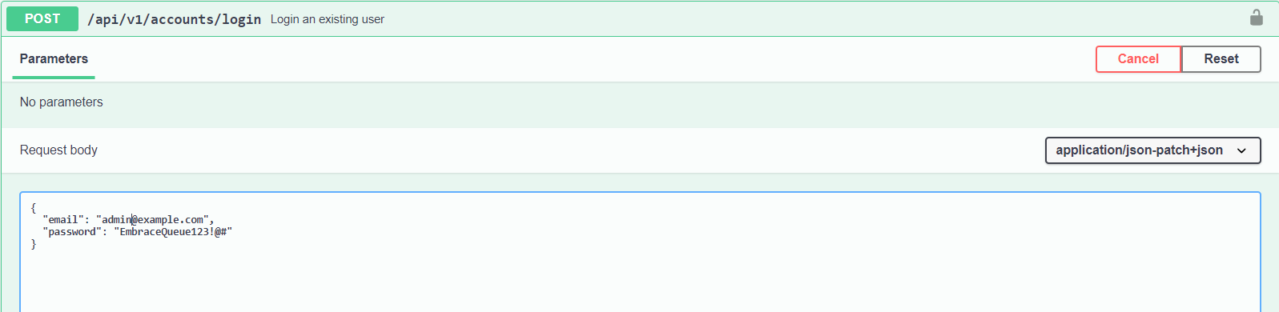

**3. Access_token (bearer token)**  should be returned after logging into system. Like in image bellow:

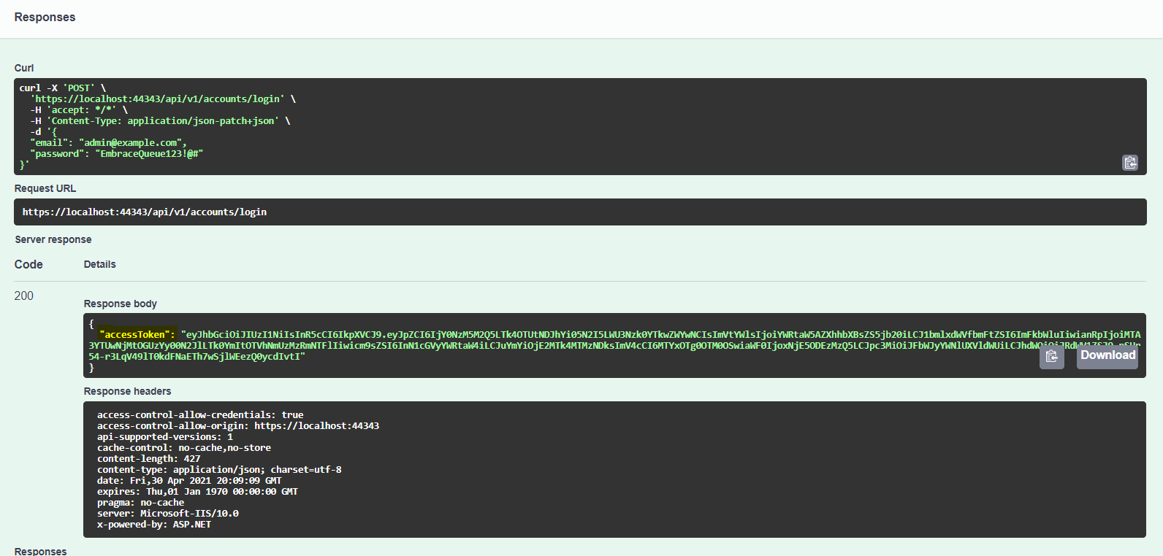

**4. Use** this **access_token** as header in your calls from postman or authorize using swagger as in following image:

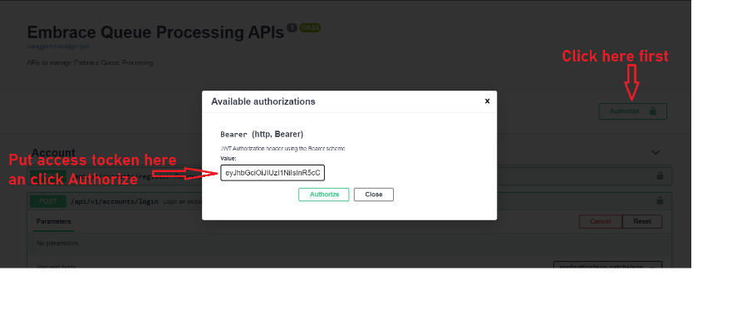

**Postman example:**

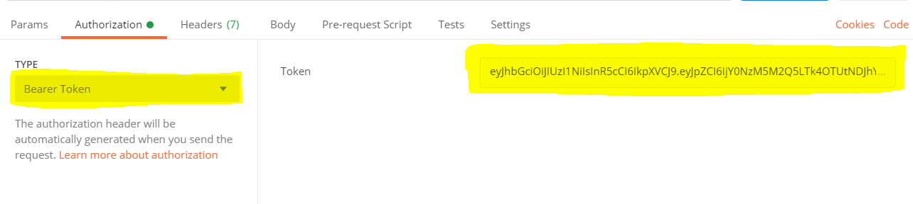

**DONE! You are able to use APIs.**

**Entities and Roles Privileges**

1. SuperAdmin and BranchManager: implement all functions for these entities (Category, Company, Branch, Location, WorkingDay, Service, ServiceLine)
2. Help Desk Employee and End User: can implement List and Find (two types) for these entities

**Account privileges**

1. Super Admin can Add **users** of Branch Manager role and Help Desk Employee role, along with Edit, Delete, List, Find.
2. Branch Manager role can Add users of Help Desk Employee role, along with Edit, Delete, List, Find
3. Branch Manager can implement List and Find for **users** of End User role.